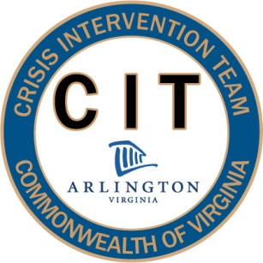
40 Hour CIT Curriculum 2012
Presentation Descriptions

Special Populations: Post-Traumatic Stress Disorder (PTSD), Traumatic Brain Injury (TBI) and War Veterans (2 Hours)
This segment will explain the DSM-IV diagnostic criteria for Post-Traumatic Stress Disorder, including causes and common treatment modalities. Local resources for veterans will be highlighted, in order to provide officers the most current information on veteran care. Instructors will offer an overview of common warning signs to be mindful of when approaching a subject that might be experiencing PTSD, as well as suggestions for officers on best practices when interacting with this population. A veteran diagnosed with this disorder will be on hand to discuss experiences and to answer questions.

