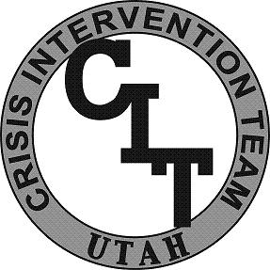
CIT Utah
Academy

Learning Objectives
Below is an outline of the minimum content and activities in each unit of the Academy.
Unit 18 : Scenario Training

Participants will learn intervention strategies through scenario based training. The participant’s interaction will be evaluated and discussed by mental health professionals and experienced CIT Officers. Participants will also be required to demonstrate minimum standards in five of the scenarios to be allowed to continue into the written testing portion of the testing process. These five scenarios are conducted in an off-site location to create a greater sense of realism. Training experiences are covered by interaction with the following or similar:

- Suicidal subjects
- Persons with developmental disorders
- Persons with co-occurring disorders
- Persons with personality disorders
- Persons with psychotic disorders
- Persons with mood disorders
- Persons with PTSD
- Persons with delusional disorders

