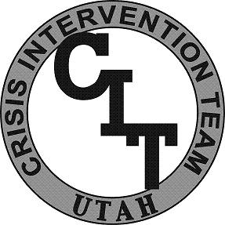
CIT Utah
Academy

Learning Objectives
Below is an outline of the minimum content and activities in each unit of the Academy.

Unit 14 : CIT Procedures
Participants will learn of CIT procedural recommendations. The following learning objectives are covered:
- CIT response flow chart review
- Dispositions
- Calls for assist
- Transportations
- Juveniles
- Documentation

