PTSD: Post Traumatic Stress Disorder/ VA
INSTRUCTORS:

Objective:
What is ASD & PTSD?
What causes it?
Who gets it?
Recognition of the signs and symptoms.
Explored statistics.
Positive steps of resistance.
Grounding communication techniques.
Knowing does not limit your Use of Force options.

What is it?
A type of anxiety disorder that is triggered by:
Having a confrontation in or being a witness to an extremely traumatic event.
Events that involve actual or threatened death or serious injury, or a threat to the physical integrity of self or others”

The History of PTSD
Soldiers Heart Evolved to describe soldiers from Civil War

Combat Fatigue / Described soldiers from WWI
Shell Shock

Battle fatigue / gross stress reaction

Described soldiers from VN, later evolved to PTSD in the 1980’s

Traumatic Stress Neurosis Described soldiers from WWII

What does not cause PTSD?
No people of a certain age or from a certain social or economic or ethnic background!

ANYONE CAN BE AFFECTED BT PTSD !

What Causes PTSD?
“Experiencing by : witnessing, or confrontation with an event or events that involve actual or threatened death or serious injury, or a threat to the physical integrity of self or others”

What causes PTSD?
Witnessing what? Most commonly R
Death or Injuries
Exposure to combat
Aggravated assaults
Natural disasters

People at Risk for Developing PTSD
First responders
Diagnosis of life threatening illness

People at Risk for Developing PTSD
According to the National Institute of Mental Health, the traumatic events most often associated with PTSD for men are rape, combat exposure, childhood neglect and physical abuse.
The most traumatic events for women are rape, sexual molestation, physical attack, being threatened with a weapon, and childhood physical abuse.

Facts about ASD and PTSD
ASD (Acute Stress Disorder) is diagnosed between 2 days and 4 weeks after exposure
ASD must show evidence of dissociative symptoms (hard time remembering, zoned out, world seems unreal)
PTSD is an anxiety disorder and is diagnosed 4 weeks after exposure
Not all who experience ASD will develop PTSD
ASD symptoms are common after exposure
Only 1/3 of those with ASD will develop PTSD
Some will develop PTSD months or years later even without ASD

Statistics
70% of adults have experienced a trauma; 20% or so will develop PTSD (80% will not)
Approx 8% or 1 in 13 people will develop ASD in their lifetime
Estimated 5% of population (13 million) will have PTSD at some point in their lives
Statistics Continued…
Rape (49 %)
Severe beating or physical assault (31.9 %)
Other sexual assault (23.7 %)
Serious accident or injury; for example, car or train accident (16.8 %)
Shooting or stabbing (15.4 %)
Sudden, unexpected death of family member or friend (14.3 %)
Child’s life-threatening illness (10.4 %)
Witness to killing or serious injury (7.3 %)
Natural disaster (3.8 %)

Iraq War PTSD Statistics:
While less than 10 % of the general population will develop post-traumatic stress syndrome
one in six soldiers returning from Iraq suffer from it.
National Center reports 24%
Enlisted men are twice as likely than military officers to report PTSD.
American women serving in Iraq / Afghanistan tend to suffer from more severe and debilitating forms of PTSD.
http://www.psychiatric-disorders.com

Consider the “Battle mind” Mindset
Battle mind is the Warrior’s inner strength to face fear and adversity in combat with courage. Key components include:
Self-confidence
- Take calculated risks
- Handle challenges
Mental toughness
- Overcome obstacles or setbacks
- Maintain positive thoughts during times of adversity and challenge

Battlemind =‘s Combat Skills
Accountability
Buddies (Cohesion)
Targeted Aggression
Tactical Awareness
Lethally Armed
Emotional Control
Mission Operational Security
Individual Responsibility
Non-Defensive (Combat) Driving
Discipline and Ordering

Hyper Sense of Justice
Black and White Thinking
Polarized Feelings toward Authority
Distorted views of “Right and Wrong”
Wrong = failure, shame, and defeat which may be expressed through anger and belligerence.
Sense of responsibility for what is “Just and Fair”.

Sense of Entitlement
Perception of Infallibility
Views disrespect as a challenge (#1 Trigger for confrontation).
Will often immediately push a boundary.
Will likely transfer their sense of entitlement to authority figures who they deem “good”

Exaggerated Response to Triggers
Stress your sense of duty (Sets Boundaries).
Recognize their service
Identify with Vet if applicable
Consider voice Intonation
Body Language, a veteran will imitate and amplify anxious or angry body language.
Co Morbid Factors
More than PTSD
Cognitive Delay
Hearing problems
Hostile Affect
Paranoia
Depression
Anxiety
Unidentifiable physical handicap

Symptoms
PTSD is characterized by three (3) primary symptoms
Re-Experiencing
Avoidance
Increased Arousal / Hyper-vigilance
Some nervous system arousal symptoms that were not present before trauma
Survival mode (red)
Sleep
Anger
Concentration

Symptoms must last at least one month and cause significant distress in social, occupational, or other areas of functioning.

Associated Symptoms
Depression
Despair and hopelessness
Challenging ones core beliefs (safety, trust, power/control, esteem & intimacy)
Aggressive behavior

Associated Symptoms
(Secondary Emotions)
Self-blame, guilt, or shame Discord in relationships
Social isolation
Physical health problems
Alcohol and drug abuse

Prevention
Talk
Relax daily
Eat healthy, exercise
Stay socially involved
Pre-exposure to trauma
Limit alcohol
Limit caffeine & nicotine intake
Manage your time
Practice sleep hygiene
Do fun activities
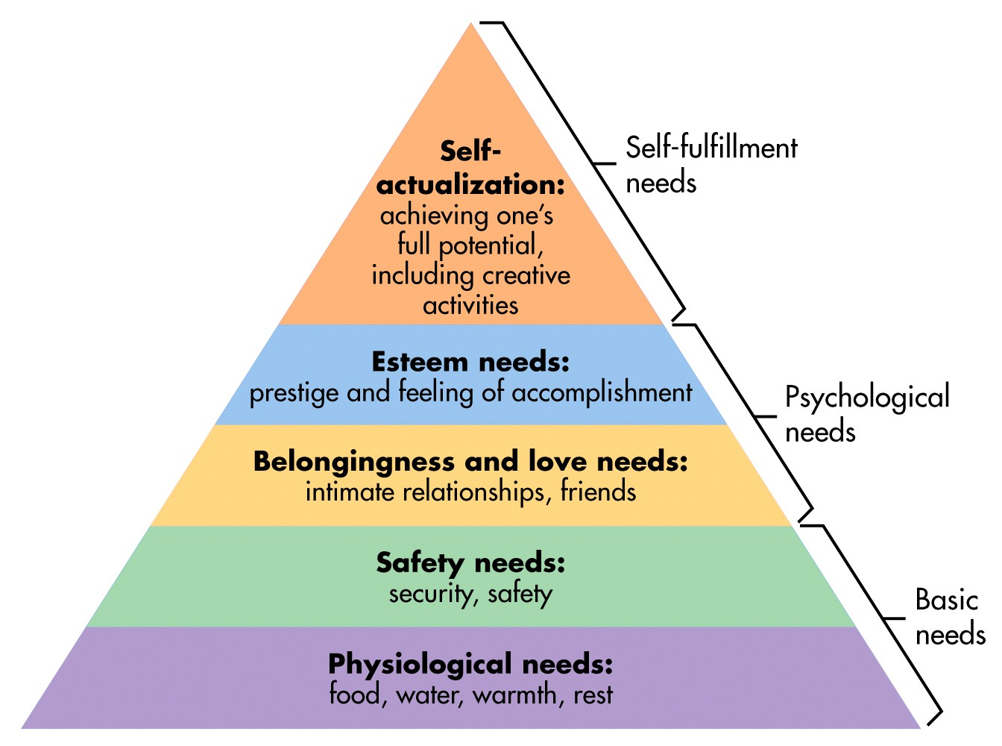Primary Symptoms Encountered by Law Enforcement
Hyper-vigilance
Dissociation
Five Key Issues
- Safety
- Trust
- Power and Control
- Intimacy
- Esteem

Techniques
Grounding Techniques
Where are you?
Who are you?
Building Rapport
Empower
Warning:
APPROACH WITH CAUTION!!
Questions/Comments?

In Summary
What is ASD & PTSD
What causes it
Who gets it
Recognition of the signs and symptoms
Explored statistics
Positive steps of resistance
Grounding communication techniques
Knowing does not limit your Use of Force options
Resources
www.ptsd.va.gov
www.mental-health-today.com/ptsd/resources.htm
http://www.giftfromwithin.org/
http://www.nlm.nih.gov/medlineplus/posttraumaticstressdisorder.html

Any Questions?

