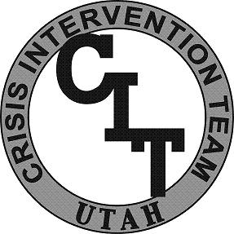
CIT Utah
Academy

Learning Objectives
Below is an outline of the minimum content and activities in each unit of the Academy.

Unit 9: Post Traumatic Stress Disorder (PTSD)
Participants will become aware of PTSD issues. The following learning objectives are covered:
- Define Post Traumatic Stress Disorder.

- List the causes of PTSD.

- List the symptoms of PTSD.

- Understand effective treatment strategies for PTSD.

- Learn effective intervention strategies for PTSD.

- Gain insight from consumer discussion.

