Psychotropic Medications
INSTRUCTORS:
Goals
- Identify what medications are used to treat the various psychiatric illnesses.
- Identify how long it takes the medications to work.
- Identify the most common side effects.
- Identify the symptoms if a patient overdoses.
- Identify the symptoms if a patient abruptly stops taking medication.

How do medications work?
Just as aspirin can reduce a fever without curing the infection that causes it, psychotherapeutic medications act by controlling symptoms
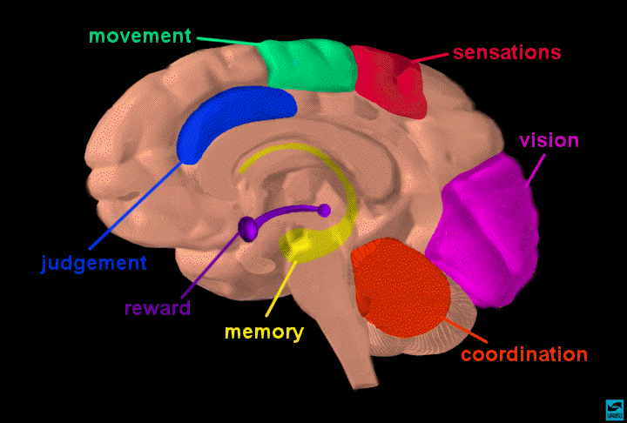
- Areas of the Brain

Symptom Relief
The degree of response ranges from a little relief of symptoms to complete relief and depends on a variety of factors related to the individual and the disorder being treated. Some medications have side effects and others do not. Age, sex, body size, body chemistry, physical illness and their treatments, diet, and habits such as smoking are some of the factors that influence medication’s effect
Questions to ask
- What is the name of the medication?
- What is it suppose to do?
- What are the side effects and what are you suppose to do if they occur?
- Have you had any alcohol or other foods/drinks/other medications that should be avoided while on this medication?
Medications for Mental Illness
- Antidepressant
- Anti-psychotic
- Anti-manic
- Anti-anxiety
- Medications for Children/Adolescents

Schizophrenia and Antipsychotics

Treatment of Schizophrenia
* Antipsychotics-generally the newer antipsychotics. May also see combinations of antipsychotics
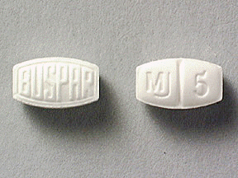
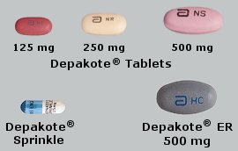
- Mood Stabilizers (especially Depakote)

- Antianxiety medications such as the benzodiazepines or Buspar
- Antidepressants-generally the newer antidepressants
Typical (Older) Antipsychotics

Side Effects
-Extrapyramidal Symptoms (EPS)
-Motor restlessness
-Increase or decrease in body temperature
-Increased or decreased heart rate
-Sedation
-Dizziness
-restlessness
-Fall in the blood pressure upon standing
Overdose-Sedation
-Decrease in blood pressure
-Arrhythmias
-Increase or decrease in body temperature
-Seizures
-EPS
-Delirium
Stopping the Medication Suddenly
-Rebound in psychosis (anywhere from 1 week to 1 month)
-nausea/diarrhea
Anticholinergic Agents
- Side Effects
-Dry mouth
-Dry eyes/blurred vision
-Not able to Urinate
-Constipation
-Increased Heart rate
-Confusion
-Memory loss
-Drowsiness
- Overdose
-Flushed
-Confused (Delirium)
-Delusional
-Increased Heart Rate
-Dehydrated
- Stopping the Medication Suddenly
-Upset stomach/diarrhea
-Slower Heart rate
-Stiffness
Atypical (Newer) Antipsychotics
- Side Effects
-Sedation
-Motor Restlessness
-Fall in blood pressure
upon standing
-Dizziness
-EPS (usually less severe)
-Metabolic syndrome
(increase in cholesterol
and lipids, and diabetes
(type 2)
-Decrease in the white
blood cells (Clozaril
-Seizures (Clozaril)
- Overdose
-Arrhythmias
-Decrease in blood pressure
-Seizures
-Decrease or Increase in body temperature
-Delirium
- Stopping the Medication Suddenly
-Relapse of treated condition such as Psychosis or Mania (anywhere from a few days to a month)
-stomach upset/diarrhea

Anxiety Disorders and Antianxiety Medications
Treatment of Anxiety Disorders
- Benzodiazepines
- Buspar
- Antidepressants (except Wellbutrin)
- Antihistamines (Vistaril, Atarax, Benadryl)
- Occasionally Antipsychotics

Bipolar Disorder and Mood Stabilizers
- Bipolar Disorder
- Characterized by cycling mood changes: severe highs(mania) and lows (depression).
- Manic’s can be overactive, overly talkative, have a great deal of energy, less need for sleep. Cannot get their thoughts out fast enough, short attention span, easily distracted, inflated ideas about their position

- Low’s mimic the depressive symptoms
Treatment of Bipolar Disorder
- Lithium (evens out the mood swings)
- Anticonvulsants especially Depakote, Tegretol, and Trileptal
- Atypical Antipsychotics (Zyprexa, Risperdal, Seroquel, Geodon, Abilify)
- Symbyax, Lamictal for Bipolar Depression
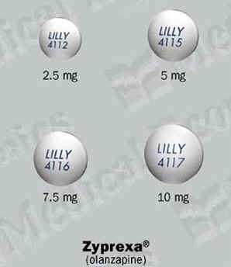
- Other medications: other anticonvulsants, Verapamil, Omega 3 fatty acids

Lithium
- Side Effects
-Fine hand tremor
-Stumbling (Ataxia)
-Increased thirst (polydipsia)
-Increased urination (polyuria)
-Slow thinking
-Decrease thyroid
-Decrease renal function

Lithium
- Overdose
-Toxic levels > 1.5 mEq/L
-Coarse Tremor
-Confusion
-Jumbled Speech
-Ataxia
-Severe nausea
- Stopping the Medication Suddenly
-Increased risk of relapse of the disorder treated
Anticonvulsants
- Side Effects
-Sedation
-Dizziness
-Ataxia
-Double Vision
-Rash
-Trouble thinking
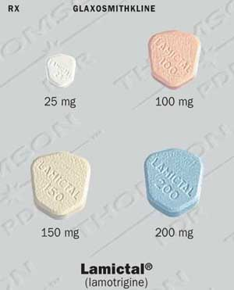
-Liver toxicity
Stopping the Medication Suddenly
-Increased risk of relapse of the disease being treated
-possible seizure
Anticonvulsants
- Depakote- at 20 times the normal level: nausea/vomiting, sedation, seizures
- -Tegretol, Trileptal-at 10-20 times the normal level: Nausea/vomiting, sedation, seizures, respiratory depression, cardiac effects
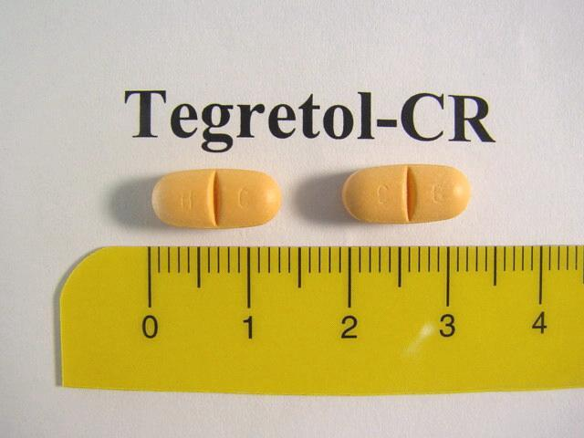
- -Lamictal-around 5 gm: swelling of the eyes, general red rash, hepatitis, renal failure, delirium

Antidepressants and Depression
- Diagnosing Depression
- Condition lasts 2 weeks or longer
- Interferes with person’s ability to carry on with daily tasks and enjoy activities that previously brought pleasure.
- Person may have no appetite and lose weight or eat more and gain weight
- Person may sleep too much or too little
- Person may express feeling hopeless, guilty and worthless
- May verbalize suicidal ideation
Treatment of Depression
- May be augmented with a different medications such as another Antidepressant, Lithium, Thyroid replacement, or the newer Anti-psychotics.
- Medications must be taken regularly as many as 8 weeks before therapeutic effect occurs.

Types of Antidepressants
- Tricyclic (older with side effects)
- MAOIs (effective with patients who do not respond to other antidepressants and effective with panic disorder and bipolar depression)
- SSRI (newer with fewer side effects)
Tricyclic Antidepressants
- Side Effects
-Confusion
-Sedation
-Fall in blood pressure upon standing (orthostasis)
-Rapid heart rate (Tachycardia)
-Dry mouth, constipation, urinary retention
-Sexual dysfunction
- Overdose
-Lethal in overdose-causes heart arrhythmias, decreased blood pressure, delirium, and seizures
- Stopping the Medication Suddenly
-Flu like symptoms
-Stomach like symptoms of diarrhea
-worsening (rebound of depression)

MAOI’s#
- Side Effects
-Insomnia
-Drowsiness
-Headache
- If taken with tyramine containing foods or medications that contain stimulants
-Hypertensive Crisis
- If taken with Serotonin medications:
-Confusion
-Unstable vital signs
-Coma
-Death

- MAOI’s#
- Side Effects
-Insomnia
-Drowsiness
-Headache
If taken with tyramine containing foods or medications that contain stimulants
-Hypertensive Crisis
If taken with Serotonin medications:
-Confusion
-Unstable vital signs
-Coma
-Death

SSRI’s*

Side Effects
-Headache
-Stomachache
-Insomnia
-Drowsiness
-Sexual
Dysfunction

SSRI’s*
Generally safer in overdose (up to 90 day supply)
-Can cause seizures in some individuals, stomach upset, and excitation or sedation
Flu like symptoms 1-7days after stopping medication
-Tingling (parasthesias)
-Nausea
-Headaches
-Rebound depression

Other Antidepressants
- Side Effects
-Desyrel, Serzone, Remeron: Sedation, fall in blood pressure upon standing, dizziness, Priaprism
-Effexor, Wellbutrin, Cymbalta: increased blood pressure, dizziness, headache, seizures, stomach upset, insomnia
Other Antidepressants

Antidepressants Causing Suicidal Ideation
- Black Box Warning is to be added to the package insert that states the possibility of increased suicidal thinking in the child and adolescent population.
- Additional handouts may be created to teach the caregivers about what to watch for.
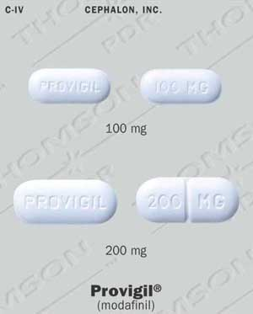
- Attention Deficit
Hyperactivity Disorder
Attention Deficit Disorder
Treatment of ADHD/ADD *
- Stimulants
- Strattera
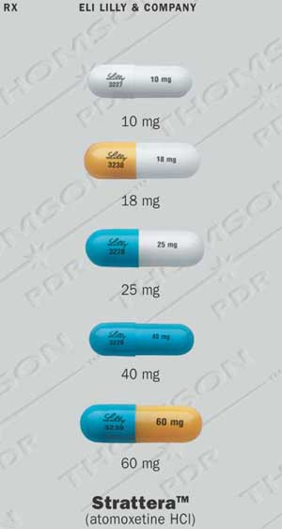
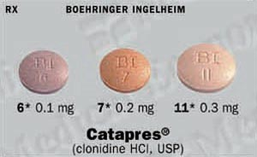
- Antidepressants such as Wellbutrin, Effexor, Tricyclic Antidepressants, rarely Parnate
- Catapres, Tenex
- Provigil
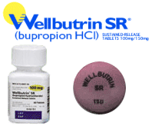
- Stimulants, Strattera,
Provigil
- Side Effects
-Decreased Appetite
-Increased heart rate and blood pressure
-Insomnia
-Nervous Tics
-Anxiousness
-Agitation
-Dizziness
-Headache
-Liver dysfunction (mainly with Cylert)

Stimulants, Strattera, Provigil
- Overdose
-Seizures
-Vomiting
-Increased heart rate
-Increased temperature
-Psychosis, agitation
-Confusion

- Stopping the Medication Suddenly
-Usually occurs within the first couple of days
-Rebound Depression
-Fatigue
-Excessive eating
-Excessive sleeping
-Rebound hyperactivity

Catapres, Tenex
- Side Effects
-Sedation
-Dry mouth
-Fatigue
-Sexual dysfunction
-Rebound hypertension if stopped suddenly

Catapres, Tenex
- Overdose
-Decreased heart rate
-Decreased body temperature
-Diarrhea
-Decreased breathing

- Stopping the Medication Suddenly
-Increased blood pressure
-nervousness, agitation, restlessness, tremor
-Insomnia
-Headache
-Stomach Spasms
-Increased saliva, sweating
- Medication Web Sites
- http://www.drugid.info/
- http://wwwmicromedex.com/products/identidex/
- http://www.lexi.com/lexistore/index.jsp
Notes:

