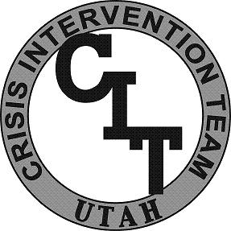
CIT Utah
Academy

Learning Objectives
Below is an outline of the minimum content and activities in each unit of the Academy.

Unit 1: Introduction
Participants are introduced to their training facilitators and expectations of the Academy. The following learning objectives are covered:
- Goals
- History
- Benefits
- Statistical concerns
- Training overview
- Program overview

