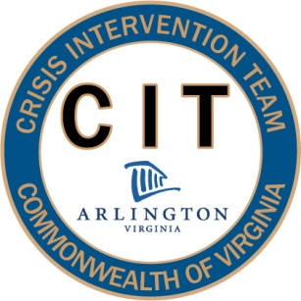
40 Hour CIT Curriculum 2012
Presentation Descriptions

Community Site Visits (4 Hours)
Officers will be taken on tours of sites within the community to facilitate a better understanding of the resources available to severely mentally ill consumers in Arlington County. Visits to the Northern Virginia Mental Health Institute, the local shelter and detox facility, and the Clarendon Clubhouse Program will be visited. A question and answer session will be conducted with facility representatives, and time will be provided during the segment on Homelessness and Community Resources to further discuss available options in the county.

